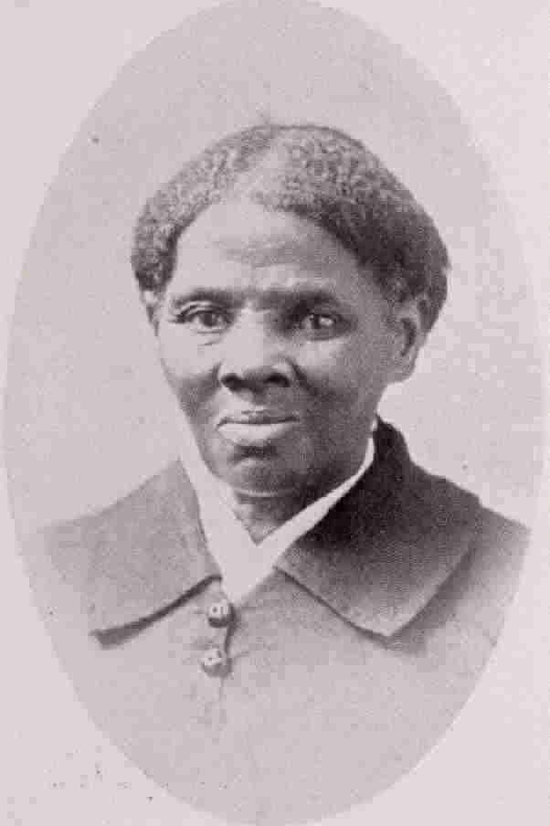
Harriet Tubman

Harriet Tubman was born in 1820 as Araminta Ross. In 1849, she escaped from slavery, leaving her husband behind after he threatened to report her plans to flee. Called “Moses” by those she saved, Harriet risked her life repeatedly over a decade to liberate slaves by secretly leading them to the north and Canada. She went on to serve as a Civil War spy, soldier, an herbalist nurse, and an activist/lecturer for civil rights, including women’s rights.

When Harriet was an adolescent, she experienced a head injury, which led to her hearing voices, having visions, narcolepsy (spells where she suddenly would fall asleep for short periods of time), and epileptic seizures. Most people know who Harriet Tubman is, but the majority of people do not know that Harriet Tubman had a disability.

Discussion Questions:

1. Here are some ways people have described Harriet Tubman’s experiences:
- “[She had] visions and [heard] voices that showed her the way to freedom… She would experience her “sleeping spells” (narcolepsy) and seizures and arise with answers for what the next move should be… Epilepsy…is said to be the mark and calling of a healer in many African traditions…referred to as the “sacred illness…” - (www.truelivingwaters.org)
- “When she was about 10 years old, she suffered a blow to the head…with such force that she would suffer from headaches, seizures, and sleeping spells…historians identify as temporal lobe epilepsy (TLE). According to [some historians], “epiphany-like” spiritual manifestations are a common side effect of TLE. These manifestations, along with her deep Christian faith, enabled Tubman to be directed…in her rescue missions.
(Gill, March/April 2004, Crisis)
- “She was raised under harsh conditions, and subjected to whippings even as a small child. At the age of 12 she was seriously injured by a blow to the head, inflicted by a white overseer for refusing to assist in tying up a man who had attempted escape.”
(www.nyhistory.com)
- “Early in her life, she suffered a traumatic head wound when she was hit by a heavy metal weight thrown by an irate overseer, intending to hit another slave. The injury caused disabling seizures, headaches, powerful visionary and dream activity, and spells of hypersomnia which occurred throughout her entire life. A devout Christian, she ascribed her visions and vivid dreams to premonitions from God.”
(Wikipedia)

Questions for Discussion:
1. What do you notice about the way they describe her disability? What might that tell you about their point of view about Harriet Tubman or about disability itself? Who do you think comes closest to the truth? Who comes closest to describing things as Harriet Tubman might have described them?

2. Based on these descriptions, do you think Harriet Tubman had a “disability”? Why or why not? How might your answer change if you were a person living in Harriet Tubman’s time? Or if you were a person who has epilepsy or narcolepsy?

3. Why do you think the average person knows Harriet Tubman, but does not know about her disability?
4. What other famous people do you know who have disabilities? What do you notice about who these people tend to be or which disabilities they had? Why might our culture teach children about those famous people as “disabled” but not Harriet Tubman?
5. How might this activity inform the way you include disability in the curriculum? How does it affect your own understanding of disability? In what ways could you do this activity in your classes?

